1.Introduction: Overview Apple is an American corporation that develops and sells computer electronics, software, personal computers and portable devices internationally. Founders Steve Jobs, Steve Wozniak and Ronald Wayne established Apple in 1976, with its incorporation in 1977. Apple has a history that spans over 30 years, and during that time the company has experienced its ups and downs in financial performance. It was after 2007 when Apple finally achieved widespread success with the launch of the iPhone, the iPod touch and the iPad. Purpose As of August 2012, Apple has 393 retail stores in fourteen countries. Apple is also the third-largest mobile phone maker after Nokia and Samsung. Recently, it introduced a variety of new products such as the iPhone 5, iPad mini, iPad 4 and the All-new iMac. The reported net income of the fourth quarter is about 24% higher than that in the year-ago quarter 2. Problem Definition & Design Thinking: Empathymap 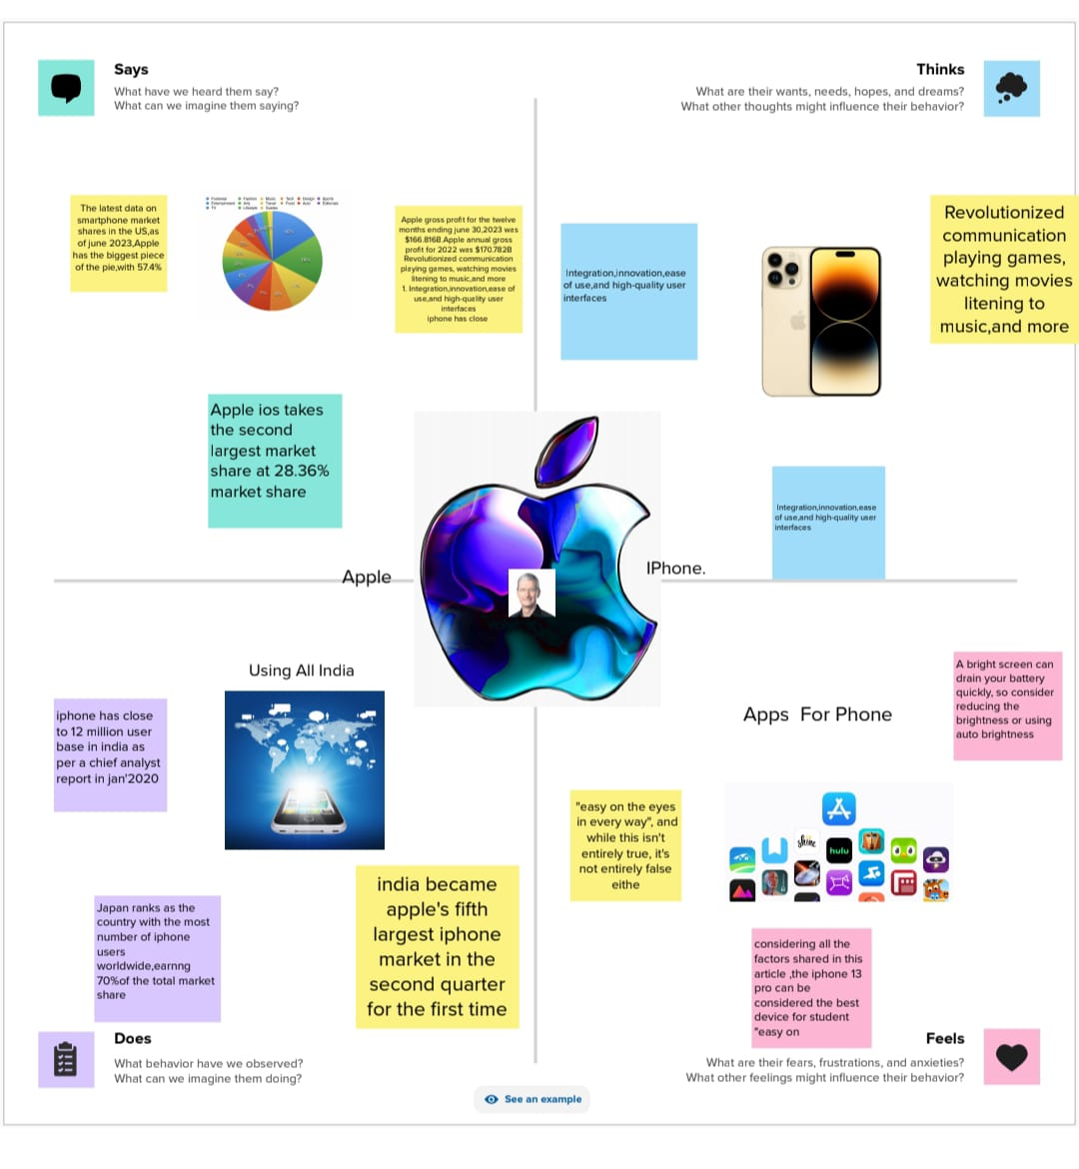

Ideation & Brainstorming Map 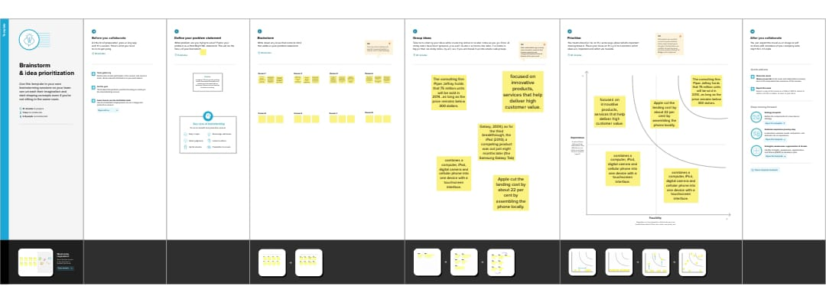

3.Result: Dashboard

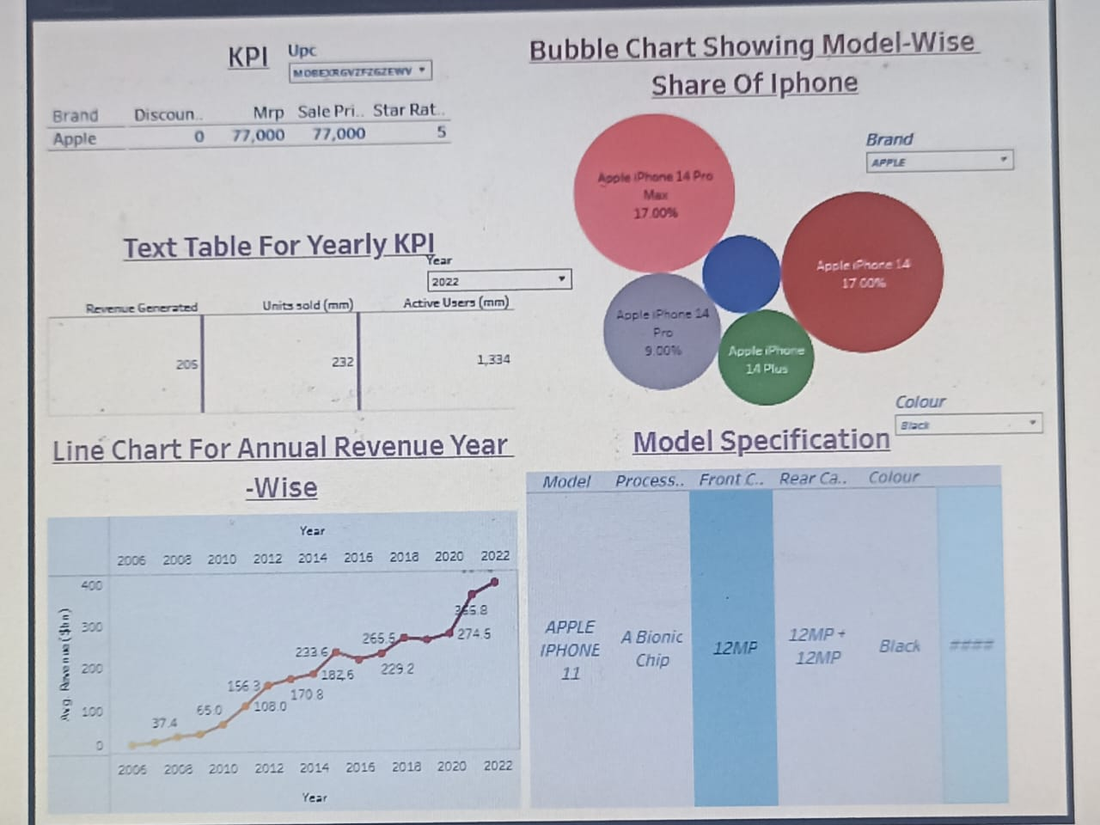

Stroy

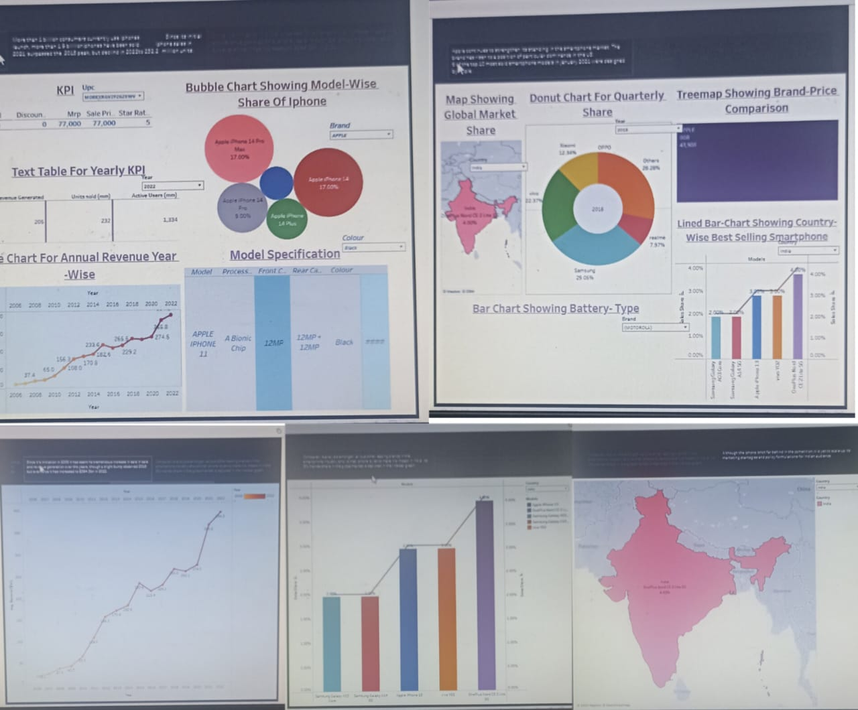

4.Advantages: **The iPhone has been one of the most preferred smartphones for many people. It continues to be a revolution in accessing the internet and the digital world. The iPhone is a technological marvel that has transformed the way people communicate and go about their daily lives.**

**1. User-Friendly Interface**: The iPhone has an intuitive user interface that makes it easy to navigate. The touch screen interface is easy to use, and the iPhone’s smooth operating system is simple to learn and use.

**2. High-Quality Display:** The iPhone’s Retina display is one of the best in the market. With a density of over 300ppi, pictures and videos appear clear and crisp. This high-quality display is perfect for streaming TV shows, movies, and graphic-intensive games.

**3. Advanced Camera**: iPhone devices have some of the best cameras in the market. They have been known to produce stunning images and videos of the highest quality. They also come with image stabilization features that help reduce blur and take better pictures in low light.

**4. Apps Ecosystem**: The App Store is unparalleled in terms of access and ease of use. With millions of apps to choose from, users have access to a plethora of tools, games, and services that cater to their needs.

**5. Seamless Integration with other Apple devices**: The iPhone has a seamless integration with other Apple devices such as MacBook, iPad, and Apple Watch. It allows users to access and transfer data across multiple devices.

**Disadvantages**

**1. Cost**: The iPhone is one of the most expensive smartphones on the market. High-end models can cost over $1000, which makes it a luxury item for many people.

**2. Non-Removable Battery**: The iPhone’s batteries are non-removable, which means that users cannot replace them. This can be a disadvantage for people who rely heavily on their phones and have to replace them regularly.

**3. Limited Customization**: One of the disadvantages of the iPhone is that it has limited customization options. Unlike Android devices, users cannot customize their phone’s interface, which can be a disadvantage for some people.

**4. No Expandable Storage**: Another disadvantage of the iPhone is that it has no expandable storage options. Users have to purchase iPhones with larger storage capacities, which can be costly.

**5. Frailty**: The iPhone is known to be fragile and prone to breaking if dropped. Many users have reported cracking or shattering their screens after accidentally dropping their devices.

In conclusion, the iPhone has been a game-changer in the technological world. It has revolutionized the way people communicate and access information. However, its advantages and disadvantages must be weighed carefully by potential buyers. Ultimately, the choice of whether to purchase an iPhone depends on the user’s preference, needs, and budget.

6.conclusion:

Apple and the IPhone is a great example of a corporation making what the consumer wants in a global market. With limited companies competing, competition for the best phone on the market is at an all-time high. With the iPhone you get better quality and better security when dealing with your personal information.

Apple Inc.’s problem is their diverse product line, which could become obsolete. In addition, there is increasing competition in the markets that Apple competes in. For example, Windows, Samsung and Blackberry are also emerging as players in the portable devices market. Furthermore, companies are competing not only in product design, but also in functionality and affordability.

Our alternatives, which will be discussed in our report, will revolve around developing and maintaining Apple’s image as a leader.

Innovation and technological advancements have keep the iPhone and Apple ahead of its competitors in this tight notch market. With the iPhone being so popular and in high demand, estimated shortages are suspected

7.Future Scope:

It's anticipated that future iPhones might incorporate some of these advanced display technologies, such as mini-LED or micro-LED, to deliver stunning visuals in a compact form factor. These technologies offer higher brightness, better contrast ratios, and more power efficiency compared to traditional OLED screens.

But in the future, the most important part of the iPhone might be everything around it. That's according to analysts who've observed the mobile industry's general trends and Apple's strategy.